Chapter 12
Future Outlook: Toward Autonomous Soil Monitoring and Restoration
Gurbinder Singh Brar
Professor, School of Computer Science and Engineering, Lovely Professional University, Phagwara, India maatibrar@gmail.com
Kamalpreet Kaur
Assistant Professor, School of Computer Science and Engineering, Lovely Professional University, Phagwara, India kamalpreet.cse98@gmail.com
Abstract
Soil pollution and degradation are among the most critical challenges to global food security, ecosystem balance, and climate stability. Conventional methods of soil monitoring and remediation are labor-intensive, time-consuming, and hard to scale. Recently, advances in artificial intelligence, robotics, nanotechnology, and the Internet of Things have made it possible to build autonomous systems for performing soil management. This chapter explores the technological underpinning, applications, and societal impacts of these systems for autonomous soil monitoring and restoration. Integrating satellite data, UAV, UGV, and nanosensors with AI analytics enables autonomous soil monitoring with continuous and adaptive soil health assessment. Predictive machine learning models supported by federated and edge computing enable secure real-time decision-making. AI enhances the efficiency of bioremediation, guides robotic amendments of soils, and optimizes phytoremediation strategies. Controlled release nanomaterials improve soil fertility and degrade pollutants. Knowledge-graph reasoning, digital twin simulations, and multi-agent robotic coordination are discussed as ways of large-scale adaptive interventions. Energy-efficient AI and equitable deployment, with policy, ethical, and sustainability considerations, are emphasized. Autonomous soil ecosystems of the future should be envisioned as self-sustaining and adaptive systems integrated into global carbon farming for climate change mitigation. These autonomous restoration technologies represent a transformative frontier in pollution mitigation by marrying advanced AI with ecological innovation.
Keywords: Autonomous Soil Monitoring, AI-driven Soil Remediation, Swarm Robotics, Bioremediation, Data Fusion, Sustainability, Federated Learning, Digital Twins, Soil Nanotechnology

1. Introduction
The most important resources to support human civilization are soil. It forms the basis for terrestrial ecosystems, secures global agriculture, regulates hydrological cycles, and plays a crucial role in the carbon cycle. At the same time, severe soil degradation has taken place worldwide due to continuously increasing anthropogenic pollution, unsustainable agricultural practices, industrial discharges, and urbanization. As a result of erosion, salinization, acidification, chemical contamination, and loss of biodiversity, more than a third of the world's soils are considered to be moderately to strongly degraded, according to the Food and Agriculture Organization of the United Nations. These factors directly affect climate resilience, water quality, and food security.
Though effective in controlled conditions, traditional soil remediation and monitoring approaches tend to be manual, time-consuming, labor-intensive, and geographically limited. Whereas remediation practices such as excavation, washing, or chemical stabilization are performed by conventional machinery, soil sampling campaigns often require weeks of laboratory analysis. These cannot match the enormous and increasing global challenge presented by soil degradation. (Valentini et al., 2025)
A revolutionary opportunity is presented by recent developments in robotics, nanotechnology, artificial intelligence (AI), and the Internet of Things (IoT). They make it possible to develop self-sufficient soil monitoring and remediation systems that can function continuously, adaptively, and economically over wide areas. With little human oversight, these systems can restore soil health by combining robotic intervention, autonomous decision-making, and real-time sensing.

This chapter reviews prospects for autonomous soil monitoring and restoration systems. It highlights sustainability, policy, and ethical issues and synthesizes advances in robotics, swarm intelligence, digital twins, data fusion technologies, and AI-driven soil science. An autonomous soil ecosystem management paradigm is envisioned wherein self-governing machines work in unison under the guidance of AI models to clean up contaminated soils and maintain environmental and food security at the global scale.

2. Emerging Paradigm: Autonomous Soil Monitoring

Autonomous soil monitoring is an innovative development in the agricultural and environmental sciences. Autonomous systems are quite the opposite of conventional approaches to soil analysis, which predominantly rely on human interpretation, laboratory processing, and manual sampling. Instead, these systems integrate robotics, AI, advanced sensing technologies, and IoT to set up frameworks for continuous real-time and adaptive appraisal of soil health. This paradigm ensures scalability, reliability, and accuracy over extensive and diversified landscapes with a reduction in expenses and human labor. (Dalle Vaglie et al., 2025)

2.1 Limitations of Traditional Soil Monitoring
Soil sampling campaigns conducted at predetermined locations and intervals are the foundation of conventional soil monitoring. In labs, the gathered samples are examined for elements like microbial activity, organic matter, heavy metals, pH, and nutrient content. Despite being accurate, this procedure has several drawbacks:

• Time-consuming: It may take days or weeks to complete a laboratory analysis.
• Spatial Restrictions: Sampling locations frequently fall short in capturing soil variability over wide regions.
• Labor and Cost: Expenses are raised by skilled technicians, machinery, and logistics.
• Temporal Gaps: Traditional methods are unable to provide continuous monitoring of soil conditions, such as moisture and nutrient cycling, which fluctuate dynamically.

A shift to autonomous, in situ monitoring systems capable of delivering high-resolution spatiotemporal data is required due to the limitations. (Bancheri et al., 2025)

2.2 Technological Foundations of Autonomous Monitoring

2.2.1 In-situ Nanosensors
Pollutants like hydrocarbons, pesticides, heavy metals, and nutrient levels can be detected in real time by nanoscale chemical and biosensors.
Examples include:
- Electrochemical nanosensors for pH, nitrate, and phosphate.
- DNA biosensors for detecting specific soil pathogens.
- Quantum dot sensors for heavy metal detection.
These sensors can be embedded in soil or mounted on robotic platforms to continuously stream data.

2.2.2 Remote Sensing Platforms
Autonomous soil monitoring integrates Unmanned Aerial Vehicles (UAVs), Unmanned Ground Vehicles (UGVs), and satellites:
• The vegetation indices, like the NDVI, which correlate with soil moisture and fertility, are detected by UAVs equipped with multispectral and hyperspectral cameras.
• High-resolution ground truthing is made possible by UGVs' ability to place soil probes at exact depths.
• Macro-level information about soil salinity, erosion, and organic carbon storage is provided by satellites.

2.2.3 AI for Predictive Analytics
Using machine learning, deep learning, and federated learning to forecast soil health parameters like moisture, fertility, carbon, and contaminants using sensor data, artificial intelligence (AI) enhances predictive analytics in autonomous soil monitoring.
Regression trees and boosted ensembles are examples of commonly used machine learning models for soil moisture predictions. Simpler tree models provide interpretability in a way that may be more relevant to field diagnostics, whereas boosted ensembles offer higher accuracy (lower RMSE) with better generalization. Deep learning-based data fusion integrates multimodal inputs from radar, optical, and soil databases to improve the prediction and create very accurate high-resolution 320 m soil moisture maps. With an accuracy as high as 97%, transformer-based techniques further enhance the prediction of soil properties.

In contrast, GNNs are applicable to real-world data that is unevenly sampled, as they capture both spatial and temporal patterns. In addition, FL enhances scalability and offers privacy because several local stations can share the work in jointly training predictive models without exchanging raw data. In this case, the combination of both enables proactive soil restoration and monitoring. AI-driven predictive analytics provides practical insights for sustainable soil management and agriculture by fusing interpretability, multimodal fusion, spatial-temporal learning, and secure collaboration. Temporal dependencies in soil processes could be captured with more advanced models such as LSTMs.mo

2.2.4 Edge and Federated Learning
To lower latency and bandwidth requirements, soil data gathered by IoT devices can be locally processed on edge devices. Federated learning enhances global model accuracy while protecting privacy by enabling cooperative model training across dispersed devices without sharing raw data.
Emerging AI paradigms such as edge and federated learning address issues related to scalability, latency, and data privacy. By enabling AI models to process and analyze data locally on edge devices, edge learning reduces reliance on centralized servers and ensures faster, real-time decision-making. Federated Learning (FL), on the other hand, maintains privacy and adheres to regulations like GDPR by allowing multiple devices or organizations to collaborate on training a shared global model without exchanging raw data. When combined, these approaches provide businesses with the ability to leverage distributed intelligence, optimize network performance, enhance security, and support automation and predictive analytics in modern workflows.

2.3 Comparative Advantage of Autonomous Monitoring
Table 12.1 contrasts autonomous and conventional monitoring based on several factors, including cost, scalability, accuracy, and efficiency. It highlights how autonomous systems utilize automation, artificial intelligence, and the Internet of Things to deliver real-time, adaptive, and more reliable monitoring compared to traditional methods, which primarily rely on manual labor and limited data.
Table 12.1: Traditional vs. Autonomous Soil Monitoring Systems
Parameters | Traditional Monitoring | Autonomous Monitoring
Data Collection | Manual sampling | Continuous, automated
Spatial Resolution | Low (few samples) | High (dense grid)
Human Involvement | High | Minimal
Time Efficiency | Time Efficiency | Near real-time
Adaptability | None | Self-learning, adaptive
Cost (Long-term) | High | Decreasing with scale
Data Accuracy | Prone to human error | High precision with automated sensors
Scalability | Limited due to manpower | Easily scalable across large networks
Decision-making | Delayed, reactive | Fast, predictive, proactive
Environmental Impact | High due to repetitive field visits | Lower, as remote monitoring reduces travel

3. Intelligent Soil Remediation Systems
Monitoring alone is insufficient without active restoration. AI-enabled autonomous systems can deploy targeted remediation interventions such as microbial inoculation, chemical neutralization, or robotic tillage with unprecedented precision. (Shalini et al., 2024)

3.1 Bioremediation with AI Optimization
The process of bioremediation involves using living things, mostly microorganisms, to break down or purify dangerous materials found in soil. Among the most persistent pollutants are hydrocarbons, pesticides, and heavy metals, all of which microbes like Pseudomonas, Bacillus, and Aspergillus species have shown a strong ability to degrade. However, environmental factors like moisture content, pH, oxygen concentration, and nutrient availability have a significant impact on microbial efficiency. Conventional remediation techniques are based on set procedures and frequently don't adjust to the changing conditions of the soil. (Jana et al., 2024)
This process is transformed by artificial intelligence (AI), which uses feedback control and predictive modelling to modify the conditions for microbial growth dynamically. To maintain an environment that supports optimal microbial activity, AI algorithms, for example, can evaluate continuous sensor data on soil nutrient levels and suggest precise nutrient amendments. Similarly, several microbial-pollutant interactions can be simulated using reinforcement learning, enabling the selection of conditions that optimize biodegradation rates. The biodegradation process can be mathematically expressed as
$$\frac{dC}{dt}=-K_{AI} . C^{α }$$
where:
- C = pollutant concentration,
- $K_{AI}$= AI-optimized rate constant, dynamically adjusted using machine learning predictions,
- α = reaction order, determined experimentally for each pollutant–microbe system.

3.2 Robotics for Precision Soil Amendment
Conditioners like compost (to replenish organic matter), lime (to neutralize acidity), or biochar (to adsorb contaminants and improve soil structure) are often needed for soil remediation. These amendments are typically applied by hand or with large machinery, which leads to ecological disturbance, inefficiency, and uneven distribution. (Pandey et al., 2025)
Amendments can be precisely injected at the desired depth and location by Unmanned Ground Vehicles (UGVs) outfitted with soil-penetrating sensors and AI-driven guidance systems. For instance, if UAV imagery or nanosensors identify a localized hotspot of cadmium contamination, a UGV can find the area on its own and deliver organic amendments or chelating agents right to the contamination site. Both chemical use and soil disturbance are decreased by this focused intervention.
Additionally, liquid bioremediation agents like microbial cultures, biosurfactants, or nutrient solutions can be sprayed over wide areas by Unmanned Aerial Vehicles (UAVs). UAVs can adjust the dosage and spraying pattern based on the spatial density of pollutants by using AI-based mapping.
This precision remediation improves overall pollutant removal while using fewer resources. According to studies, robotic soil amendment powered by AI can save up to 40% on chemical use when compared to traditional bulk applications, all the while speeding up the restoration of soil fertility. (Raviteja & Reddy, 2023a)

3.3 Nanotechnology and Controlled Release
AI models improve this process by forecasting optimal combinations of plants and pollutants. By integrating knowledge of soil chemistry, pollutant distribution maps, and plant physiological models, AI may be able to recommend species with the best uptake potential at a given contaminated site. In addition, reinforcement learning will guide robotic cycles of planting and harvesting. For example, a robotic planter may measure pollutant uptake rates, try out many different spatial arrangements, and learn from experience.
AI is essential to optimizing the deployment of nanoparticles. Machine learning models are able to pinpoint the exact sites where nanoparticles should be applied and forecast the patterns of pollutant migration in soil. AI-generated deployment maps can then be carried out by UGVs and UAVs, releasing nanoparticles only where necessary.
Additionally, by mimicking soil temperature, pH, and microbial activity, AI can control the release kinetics and guarantee that nanoparticles only release their payload in the best possible circumstances. (Raviteja & Reddy, 2023b)

In addition to speeding up the breakdown of pollutants, this combination of AI and nanotechnology increases soil fertility. To enable simultaneous remediation and fertility restoration, for example, nanoparticles containing nitrogen-fixing agents or plant-growth-promoting rhizobacteria (PGPR) can be released alongside compounds that degrade pollutants.

3.4 Phytoremediation Optimization
Phytoremediation uses plants to remove, stabilize, or breakdown contaminants present in the soil. Certain hyperaccumulator plants may effectively absorb heavy metals such as arsenic, cadmium, and lead; examples include Helianthus annuus and Brassica juncea. However, selection of the right species for a particular pollutant and optimization of their planting densities, patterns, and harvest frequencies is crucial for the effectiveness of phytoremediation.
AI models enhance this process by predicting the best combinations of plants and pollutants. By combining data on soil chemistry, pollutant distribution maps, and plant physiological models, AI can suggest species that show the best potential for uptake at a particular contaminated site. Moreover, robotic cycles of planting and harvesting could be regulated using reinforcement learning. For example, a robotic planter would monitor pollutant uptake rates, try different spatial arrangements, and learn iteratively.

The effectiveness of pollutant removal has been shown to significantly increase with AI-driven phytoremediation. In comparison to traditional phytoremediation techniques, the efficiency of pollutant uptake can be increased by 25–40% by combining species selection, optimal planting density, and robotic harvesting. Secondary advantages of phytoremediation include soil stabilization, erosion reduction, and increased soil organic carbon. (Akeem Akinkunmi Akintola, 2024)

3.5 Comparative Efficiency
The efficiency gains made by AI-driven remediation approaches can be quantitatively compared to traditional manual methods. Table 12.2 presents a comparative analysis of how AI-driven soil remediation outperforms traditional manual methods for a wide range of pollutants. The AI-based intervention with adaptive optimization of microbial and phytoremediation processes achieves 20–40% higher efficiency for heavy metals, hydrocarbons, and pesticides. In the same way, AI-controlled irrigation and target soil amendments reduce recovery times (with improvements in long-term soil health) for acidic, saline, and nitrate runoff soils. (Li et al., 2023)
Whereas manual cleanup remains very resource-intensive and ineffective for complex pollutants such as industrial chemicals and microplastics, AI-driven nanotechnology and predictive modeling now enable targeted degradation, lowering costs and ecological disturbance. Of more importance is the time efficiency of AI methods: robotics and reinforcement learning algorithms can scale down processes that take decades, such as acid mine drainage and microplastic removal, to manageable times .
Under AI regimes, the ecological footprint is also significantly reduced because interventions are more accurate, reducing secondary pollution and preventing excessive chemical use. Therefore, AI-driven remediation not only improves the effectiveness of pollutant removal but also fosters scalability, cost-effectiveness, and sustainability for soil management in the future. (Navarro et al., 2025)

Table 12.2: AI-driven vs. Manual Remediation Efficiency
Pollutant Type | AI-Driven Efficiency (%) | Manual Efficiency (%) | Time Required | Cost Implications | Ecological Impact
Heavy Metals (e.g., Pb, Cd, Hg) | 70–90% | 40–55% | Years to decades | High due to repeated amendments | Risk of secondary pollution; limited recovery
Hydrocarbons (e.g., oil, PAHs) |  | 50–60% | Months to years | Moderate–high (manual monitoring costs) | Enhanced microbial/plant synergy reduces toxicity
  80–95%
Nitrates & Fertilizer Runoff |  | 45–55% | Seasons to years | Moderate–high | AI minimizes over-fertilization, restores balance
  70–88%
Pesticides (e.g., organophosphates, chlorinated compounds) |  | 30–50% | Months to years | High (manual spraying + reapplication) | AI targets hotspots, reducing chemical overuse
  75–92%
Industrial Chemicals (e.g., PCBs, solvents) |  | 25–40% |  | Very high (manual excavation/disposal) | AI-driven nanotech enables targeted breakdown
  60–80%
  Years
Acidic Soils (Acid Mine Drainage) |  | 30–45% | Years | High (lime, gypsum amendments manually) | AI-controlled dosing reduces ecological disruption
  70–88%

3.6 Workflow of AI-assisted Soil Restoration

The conceptual architecture of an autonomous soil sensing system shows how several sensing and computational layers can be integrated in order to provide real-time monitoring and prediction analysis of soil health. At ground level, nanosensors are placed to measure important variables that include pH, moisture content, nutrient concentration, and the presence of contaminants. Such sensors form a dense Internet of Things network by wirelessly sending localized measurements to nearby unmanned ground vehicles serving as mobile data aggregators.

By using multispectral and hyperspectral imaging to provide large-scale spatial observations, aerial platforms like unmanned aerial vehicles (UAVs) supplement ground measurements. In order to produce both localized and regional insights into soil variability, UAV and UGV data streams are combined. (Huere-Peña et al., 2024)

After data acquisition, the multimodal inputs undergo sophisticated processing using machine learning and predictive analytics models on cloud-based AI platforms. Creation of real-time dashboards and decision-support tools visualizes trends in soil health for farmers, researchers, and policymakers. Edge computing assures low-latency responses, making the system useful for sustainable land management and precision farming. In summary, Figure 12.1 presents a layered autonomous architecture bringing together robotics, nanosensors, aerial systems, and cloud artificial intelligence that provisions proactive soil monitoring and management. (Janga et al. 2023)
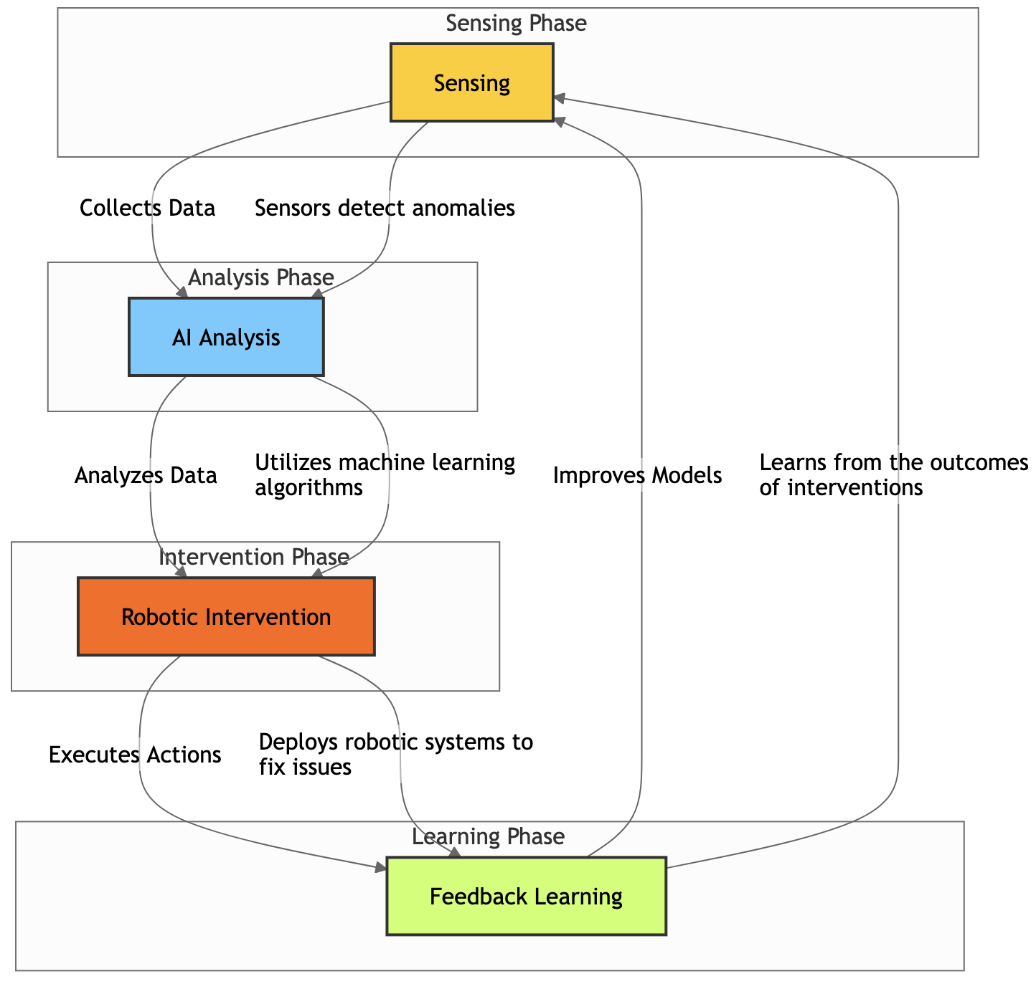Figure 12.1: Workflow diagram of the autonomous remediation cycle

4. Multi-Agent Robotic Systems for Large-Scale Restoration
The process of autonomous soil repair will require several agents to work in collaboration, including nanorobots, UAVs, and UGVs. Swarm intelligence allows for distributed, flexible, and cost-effective operations. Besides discreet AI-driven interventions, soil remediation in the future will be performed using integrated multi-agent robotic ecosystems that can perceive, deliberate, and act autonomously in a number of diverse contexts. The convergence of nanorobots, unmanned ground vehicles, and unmanned aerial vehicles makes restoration scalable, cost-effective, and flexible to deal with complex contamination situations. Swarm intelligence is what these systems are based on. It is inspired by biological collectives like termites, ants, and bees wherein basic local interactions create highly efficient emergent global behaviors. (Ritu Raj Sondhiya, 2024).

These systems are an example of the shift from static, centralized interventions to dynamic, dispersed networks of independent agents that may plan adaptive restoration, perform targeted repair, and monitor continuously.

4.1 Robotic Swarms

Swarm robotics utilizes resilience, redundancy, and decentralized coordination. Each robotic unit is programmed with basic behavioral guidelines, including pollutant hotspot recognition, soil nutrient injection, or contamination sampling. Individual robots do not have complex intelligence, but self-organization, division of work, and adaptive coverage can be manifested in the whole swarm.

Swarm robots can be used for soil remediation in the following ways:
- Apply amendments (such as compost, lime, or charcoal) evenly across the space.
- Target areas with high concentrations of heavy metals or hydrocarbon discharges.

Keep an eye on the chemistry of the soil and notify higher-level coordination layers of any abnormalities. Swarm systems' bio-inspired design guarantees resilience by allowing other robots to adaptively redistribute tasks in the case of a failure, so averting system collapse.

4.2 Coordinating UAVs and UGVs

Heterogeneous collaboration is an important characteristic of multi-agent systems. By capturing airborne imagery with multispectral and hyperspectral cameras, UAVs provide a macroscopic view while generating high-resolution maps of vegetation health indices, soil moisture, and pollution. With these airborne observations, ground-based UGVs make targeted interventions by introducing additives into the soil at specific depths, tilling the contaminated area, or injecting microbial consortia.

Decentralized AI protocols, such as the following, facilitate communication:

- Methods for consensus (such as distributed averaging) that allow UGVs and UAVs to concur on the priorities for remediation.
- Through trial-and-error interactions, robots can learn cooperative behaviors thanks to multi-agent reinforcement learning (MARL).
- Federated coordination improves scalability by guaranteeing data sharing without taxing central servers.

Because UGVs respond precisely and UAVs map zones quickly, this synergy minimizes redundancy and speeds up restoration cycles.

4.3 Architecture of Swarms

A layered swarm architecture supports large-scale restoration:

Sensing Layer: Pollutants (heavy metals, hydrocarbons, and nitrates) are continuously measured by nanorobots and in-soil microsensors. UAVs look for soil reflectance and surface vegetation.

Communication Layer: To ensure low-latency coordination, agents exchange data via edge-based cloud platforms or mesh networks.

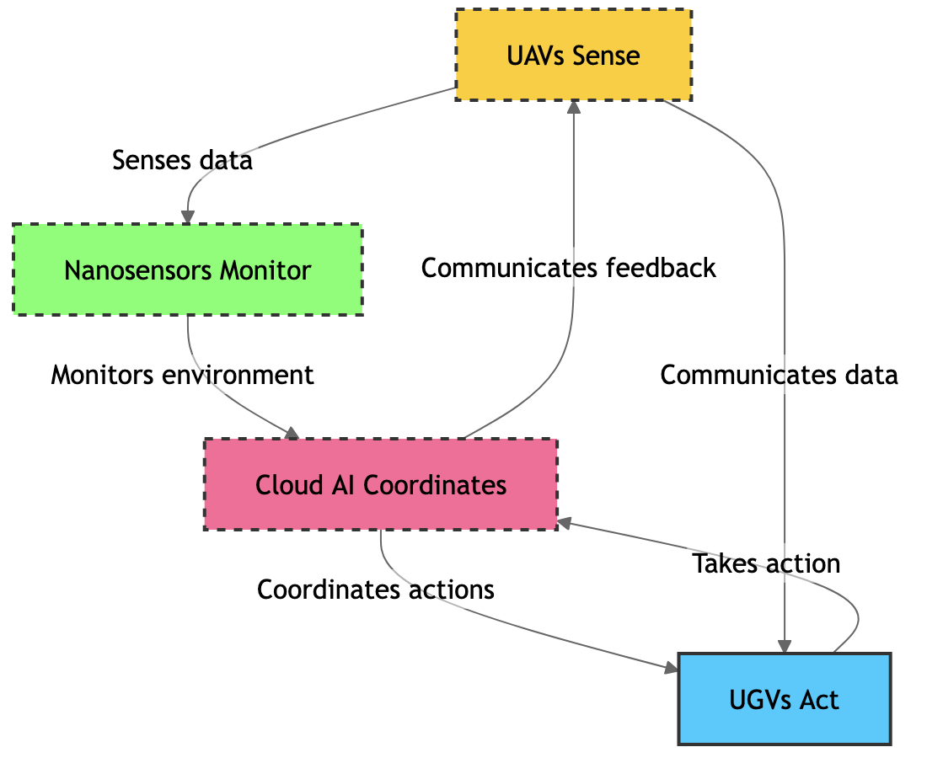

Figure 12.2: Swarm robotic framework for soil restoration

Decision Layer: AI-powered swarm algorithms decide how to assign tasks (such as which UGV responds to a hotspot that the UAV has detected).

Execution Layer: Under the direction of prediction models, ground and aerial robots carry out cleanup.

Feedback Layer: Constant monitoring and action loops enable self-correction and adaptation, strengthening the system's resistance to unpredictability.

This graphic in Figure 12.2 shows a swarm-based framework in which UAVs map and do airborne sensing to locate hotspots for soil contamination. By injecting charcoal, compost, or microbial agents into contaminated areas, UGVs carry out targeted cleanup. Real-time data is transmitted by embedded nanosensors, which continuously monitor soil characteristics like moisture, nutrients, and pollutant levels. All agents are coordinated by a cloud AI system, which maximizes task distribution and guarantees flexible cooperation. Curved arrows show bidirectional communication, solid arrows show remediation activities, and dotted arrows show aerial sensing. This multi-agent system works together to provide intelligent, scalable, and effective soil monitoring and restoration. (Bhaba Krishna Kuli et al., 2025)

Scalability is guaranteed by this modular design, from contaminated industrial areas to small-scale agricultural plots.

5. Digital Twins and Simulation in Soil Restoration
Advanced technologies that enable autonomous intervention, predictive modeling, and ongoing monitoring are driving soil restoration in the future. Manual sampling and sporadic laboratory analysis are the mainstays of traditional soil management techniques, which are frequently expensive, time-consuming, and have limited spatial and temporal precision. A comprehensive framework for autonomous soil monitoring and restoration is offered by emerging technologies like digital twins, IoT-based sensing, and AI-driven simulations, which provide proactive decision-making and precise intervention. (Tsakiridis et al., 2023)

5.1 The Idea of a Digital Twin

A virtual system that replicates a physical system's structural, chemical, biological, and hydrological properties in real time is called a digital twin. A digital twin is used to depict how soil particles, water, nutrients, microbes, and plants interact in soil ecosystems. It continuously incorporates information from integrated Internet of Things sensors that track temperature, microbial activity, pH, nutrient level, and soil moisture. The twin can dynamically update its model thanks to this constant flood of data, giving it a precise, high-resolution depiction of the soil environment. (Liu et al., 2023)

In contrast to traditional monitoring, a digital twin is not merely observational but also interactive and predictive. It tracks the results of interventions, detects areas of degradation, and visualizes soil processes at both the micro and macro scales. Soil managers can make accurate and timely interventions by using this virtual depiction to comprehend how changes in microbial communities, nutrient levels, or moisture impact the overall health of the soil. (Wang et al., 2024)

5.2 Simulation and Predictive Modeling

AI-driven simulation is the source of digital twins' predictive potential. Machine learning algorithms analyze large streams of sensor data to describe intricate interactions in soil systems and predict future states. For example, predictive models can consider the transport of pollutants across soil layers due to different conditions of moisture and temperature and then calculate the transport of pollutants, such as heavy metals or pesticide residues. These simulations allow practitioners to evaluate online restoration techniques like phytoremediation, bioaugmentation, or organic amendments without interfering with the real field. (Babanatsas & Babanatis-Merce, 2025)

Predictive modeling also supports climate-responsive soil management. Digital twins with incorporated climate data can predict how drought, heavy precipitation, or temperature changes may affect soil health, helping practitioners alter cover cropping plans, nutrient management programs, and irrigation schedules. This proactive strategy lowers operational expenses while reducing environmental risk and offering focused interventions in the most vulnerable locations.

5.3 Elements of a Digital Twin of Autonomous Soil

An autonomous soil repair digital twin system is made up of multiple interrelated layers:
The physical soil model serves as the basis for simulations by capturing the water and solute transport and representing the soil's structure, porosity, and hydrology. (An & Chen, 2023)

IoT Sensing Network: Important soil characteristics such as moisture, nutrient content, pH, electrical conductivity, and microbial activity are continuously measured by embedded sensors.
The data integration layer ensures consistency and dependability for precise simulation by gathering and processing heterogeneous sensor data.

AI Simulation Engine: Produces actionable insights by running predictive models for microbial dynamics, pollutant transport, nutrient cycles, and hydrological behavior.
The Decision Support and Control Interface can initiate automated processes like irrigation or amendment application, visualize forecasts, and suggest interventions.

Autonomous Feedback Loop: Assures ongoing communication between the digital and physical twins of soil, confirming forecasts and improving models over time.

A closed-loop system is made possible by this integrated framework, where AI-driven decisions are informed by autonomous monitoring applied to the soil, and the results are transmitted back into the digital twin to improve future forecasts. (An & Chen, 2023)
Figure 12.3: Digital Twin of Soil Ecosystem illustrates a complex integration of digital and physical systems for precise soil management. The figure shows an actual soil environment with Internet of Things sensors embedded within. Sensors continuously track vital parameters like temperature, microbial activity, moisture content, and nutrient levels. These real-time data streams feed into an AI-driven digital twin, a dynamic virtual representation of the soil ecosystem, which models the current situation, predicts future developments, and evaluates potential interventions. While dotted arrows represent the prediction input of the twin to inform soil management choices, solid arrows represent sensor-to-twin data flows. The digital twin allows for scenario testing without impact on the real soil for a variety of scenarios, like changes in fertilizer treatments or irrigation schedules. This approach facilitates sustainable agriculture, resource optimization, and improved monitoring of soil health through its continuous interactive loop between virtual and actual soil. This picture highlights the potential for intelligent, data-driven soil ecosystem management as a result of IoT and AI integration. Babanatsas & Babanatis-Merce, 2025
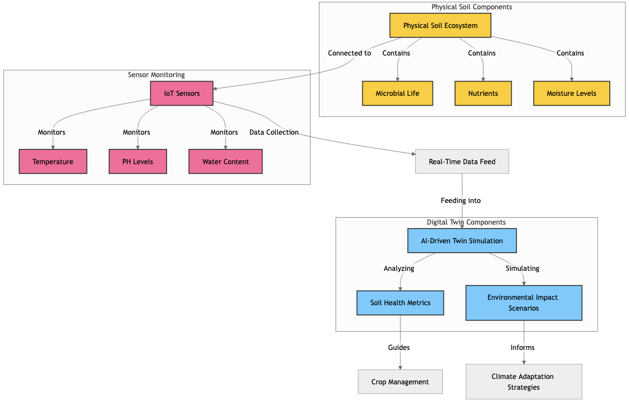
Figure 12.3: Digital twin of soil ecosystem

6. Conclusion and Future Directions
Integration of ecological science with robotics, nanotechnology, and artificial intelligence is furnishing soil management with unprecedented opportunities for self-monitoring and self-repair. Future soil management will be performed by self-regulating digital ecosystems able to respond with minimal human intervention to environmental stresses, nutrient imbalances, and pollutant concerns by integrating real-time sensing, predictive modeling, and autonomous interventions. This transition from reactive to proactive soil stewardship promises to enhance agricultural productivity, ecosystem resilience, and climate adaptation in light of the pressing issues of food security and environmental sustainability in the coming decades.
Autonomous soil technologies are a social imperative rather than merely a technical advancement. Scalable, data-driven soil management systems can protect soil productivity and health globally in the face of mounting pressures from land degradation, climate change, and population increase. This will guarantee that restoration efforts are accurate, efficient, and long-lasting. Restoration at previously unachievable landscape sizes is made possible by the capacity to continuously monitor soil health, forecast ecosystem reactions, and carry out focused interventions, which lowers economic and environmental risks.
Ethical, social, and policy issues need critical attention before autonomous soil technologies can see wide application. Success will depend upon clear legal frameworks that ensure equity in access to technology and public trust in AI-enabled ecosystems. Setting ethical standards, data-sharing procedures, and governance frameworks that can help these advances benefit society while avoiding unforeseen impact is possible only through a collaboration of scientists, legislators, farmers, and local communities.
In the future, continuous learning and multi-scale integration will be essential elements of autonomous soil management. While advances in robotics and nanotechnology may make it possible for soil amendments, microbial inoculants, or precision irrigation to be delivered autonomously, linking digital twins of soils with crop models, watershed management systems, and climate forecasting can help with landscape and regional restoration planning. Additionally, promoting citizen research and community engagement could democratize access to these technologies by creating participatory ecosystems where local knowledge improves AI-derived discoveries.
The combination of advanced technology and ecological knowledge places humankind in a position where it has the ability to preserve and repair robust soil systems globally. AI-driven autonomous soil ecosystems can balance ecological integrity, resilience, and productivity by 2050 and, therefore will be a key component in sustainable agriculture and environmental stewardship. Implementation of this vision will not only require technological innovation but also ethical, legal, and societal preparedness to make sure that autonomous soil management serves the planet and its inhabitants in a fair and efficient manner.
References
- Akeem Akinkunmi Akintola. (2024). AI-driven monitoring systems for bioremediation: real-time data analysis and predictive modelling. World Journal of Advanced Research and Reviews, 24(1), 788–803. https://doi.org/10.30574/wjarr.2024.24.1.3099
- An, D., & Chen, Y. (2023). Explainable Artificial Intelligence (XAI) Empowered Digital Twin on Soil Carbon Emission Management Using Proximal Sensing. 2023 IEEE 3rd International Conference on Digital Twins and Parallel Intelligence (DTPI), 1–5. https://doi.org/10.1109/DTPI59677.2023.10365455
- Babanatsas, T., & Babanatis-Merce, R. M. (2025). Study of the Possibility of a Conceptual Framework for Digital Twin and Cyber-Physical Systems to Enhance Sustainable Agricultural Management. https://doi.org/10.20944/preprints202507.1473.v1
- Bancheri, M., Perego, A., Botta, M., Albrizio, R., Orefice, N., De Mascellis, R., & Basile, A. (2025). From Indicators to Action: Modeling Soil Health for Ecosystem Service Optimization. https://doi.org/10.5194/egusphere-egu25-6406
- Bhaba Krishna Kuli, Joytu Debnath, Asaruddin Sheikh, Samiran Das, & Pritam Singh Balai. (2025). Smart Farming Revolution: AI, IoT, and Robotics in Precision Agriculture and Soil Conservation. International Journal of Scientific Research in Science, Engineering and Technology, 12(2), 688–706. https://doi.org/10.32628/IJSRSET25122193
- Dalle Vaglie, M., Martellozzo, F., Chirici, G., & Francini, S. (2025). Advancing Soil Health Monitoring: A Machine Learning Approach. https://doi.org/10.5194/egusphere-egu25-3300
- Huere-Peña, J. L., Castrejon-Valdez, M., Castañeda-Campos, C., Leon-Gomez, R., Mateu-Mateo, W. A., Bautista-Gómez, R., Arostegui-León, E., Dueñas-Jurado, C., Ceenti-Chancha, E. J., Rojas-Felipe, E., & Yaulilahua-Huacho, R. (2024). Innovations in Soil Health Monitoring: Role of Advanced Sensor Technologies and Remote Sensing. Journal of Experimental Biology and Agricultural Sciences, 12(5), 653–667. https://doi.org/10.18006/2024.12(5).653.667
- Jana, S., Chatterjee, D., Pal, N., Pal, K., Roy, K., & Bashak, S. (2024). AI in Soil Health Monitoring: A Data-Driven Approach. International Journal for Research in Applied Science and Engineering Technology, 12(10), 1327–1335. https://doi.org/10.22214/ijraset.2024.64871
- Janga, J. K., Reddy, K. R., & Raviteja, K. V. N. S. (2023). Integrating artificial intelligence, machine learning, and deep learning approaches into remediation of contaminated sites: A review. Chemosphere, 345, 140476. https://doi.org/10.1016/j.chemosphere.2023.140476
- Li, D., Wang, H., Ding, J., Zhou, Y., Jia, Y., Fan, S., Zhang, A., & Shen, Y. (2023). Comparative study on aerobic compost performance, microbial communities and metabolic functions between human feces and cattle manure composting. Environmental Technology & Innovation, 31, 103230. https://doi.org/10.1016/j.eti.2023.103230
- Liu, K., Qiu, T., Tian, G., Wang, R., & Liu, M. (2023). A Preliminary Study on the Research and Development of a Digital Soil and Water Conservation Intelligent Management Platform—Taking Anji County as an Example. E3S Web of Conferences, 406, 04039. https://doi.org/10.1051/e3sconf/202340604039
- Navarro, J., Briones, A., Zaballos, A., Groen, D., Helder, M., Rajaei, H., Anguera, J., Andújar, A., Carpaneto, A., Roccotiello, E., Lizzi, L., Brunelli, D., Belleudy, C., & Ferrero, F. (2025). EcoSentinel: Towards A Techno-Natural Internet of Things Approach for Large-Scale Sustainable Remote Monitoring of Soil and Wilderness. 2025 10th International Conference on Smart and Sustainable Technologies (SpliTech), 1–6. https://doi.org/10.23919/SpliTech65624.2025.11091389
- Pandey, U., Vashisth, A., Mishra, A., & Kumari, M. (2025). AI and IoT-Driven Soil Health Restoration: A Machine Learning Approach for Sustainable Agriculture. https://doi.org/10.21203/rs.3.rs-6490610/v1
- Raviteja, K. V. N. S., & Reddy, K. R. (2023a). Application of Artificial Intelligence, Machine Learning, and Deep Learning in Contaminated Site Remediation (pp. 393–407). https://doi.org/10.1007/978-981-99-1886-7_33
- Raviteja, K. V. N. S., & Reddy, K. R. (2023b). Application of Artificial Intelligence, Machine Learning, and Deep Learning in Contaminated Site Remediation (pp. 411–425). https://doi.org/10.1007/978-981-99-1388-6_32
- Ritu Raj Sondhiya. (2024). Smart Solutions for Sustainable Agriculture: Design and Development of IoT-Powered Soil Health Identification Systems. Communications on Applied Nonlinear Analysis, 31(4s), 510–519. https://doi.org/10.52783/cana.v31.946
- Shalini, V. T., Neware, R., Kumari, T., & Kumar, M. (2024). Soil Health Management Using Artificial Intelligence for Smart Agriculture Systems. https://doi.org/10.20944/preprints202409.0605.v1
- Tsakiridis, N. L., Samarinas, N., Kalopesa, E., & Zalidis, G. C. (2023). Cognitive Soil Digital Twin for Monitoring the Soil Ecosystem: A Conceptual Framework. Soil Systems, 7(4), 88. https://doi.org/10.3390/soilsystems7040088
- Valentini, R., Cecchinato, N., Castaldi, S., Chiriaco, M. V., Coppola, V., & Renzi, F. (2025). Advancing Ecosystem Service Quantification with a Low-Cost Soil Box Technology for Agroecological Systems. https://doi.org/10.5194/egusphere-egu25-19999
- Wang, Y., Wang, L., Han, W., & Yan, J. (2024). Digital twin of earth: A novel information framework for managing a sustainable earth. The Innovation Geoscience, 2(4), 100092. https://doi.org/10.59717/j.xinn-geo.2024.100092

